MFA(MultiFactor Authentication)

Multi-factor authentication is a process where a user is prompted during the sign-in process for an additional form of identification, such as to enter a code on their cellphone or to provide a fingerprint scan.

If you only use a password to authenticate a user, it leaves an insecure vector for attack. If the password is weak or has been exposed elsewhere, is it really the user signing in with the username and password, or is it an attacker? When you require a second form of authentication, security is increased as this additional factor isn't something that's easy for an attacker to obtain or duplicate.

Azure Multi-Factor Authentication works by requiring two or more of the following authentication methods:

* Something you know, typically a password.
* Something you have, such as a trusted device that is not easily duplicated, like a phone or hardware key.

Users can register themselves for both self-service password reset and Azure Multi-Factor Authentication in one step to simplify the on-boarding experience. Administrators can define what forms of secondary authentication can be used. Azure Multi-Factor Authentication can also be required when users perform a self-service password reset to further secure that process.

Steps :

Enable MFA on User Account

Go to Azure Active Directory

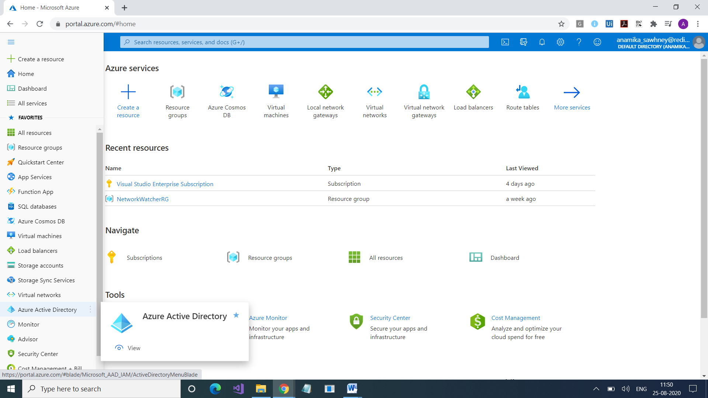

Go to Users

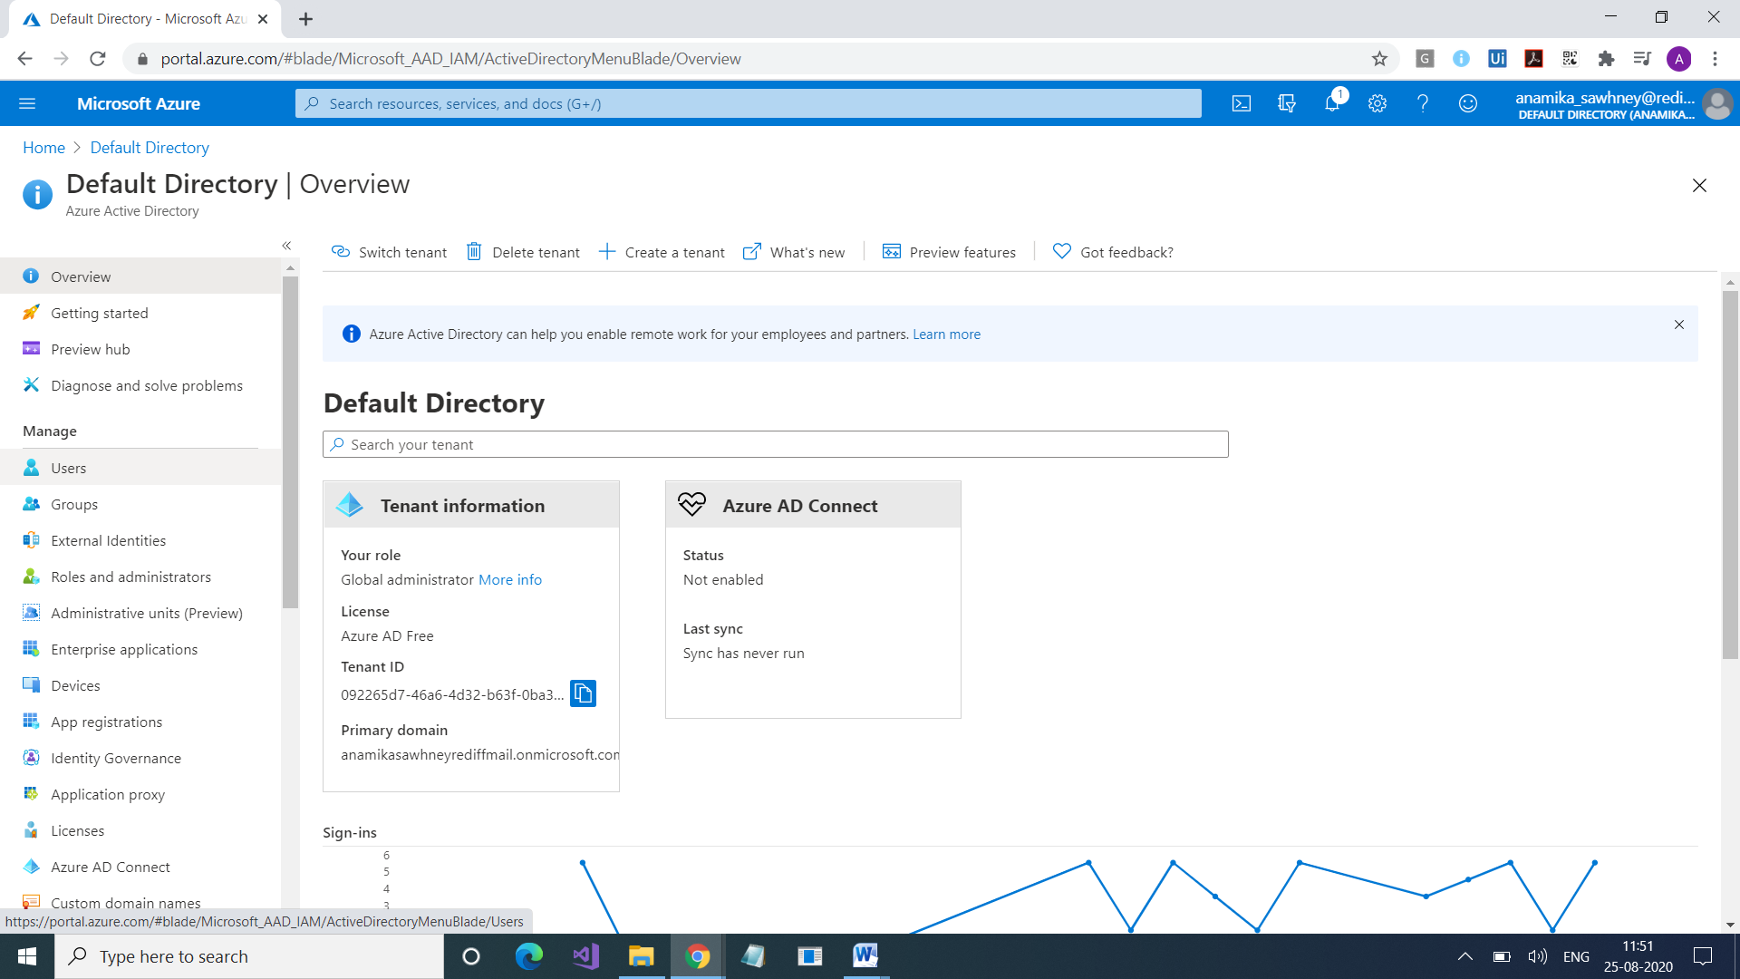

Select User and Select MultiFactor Authentication

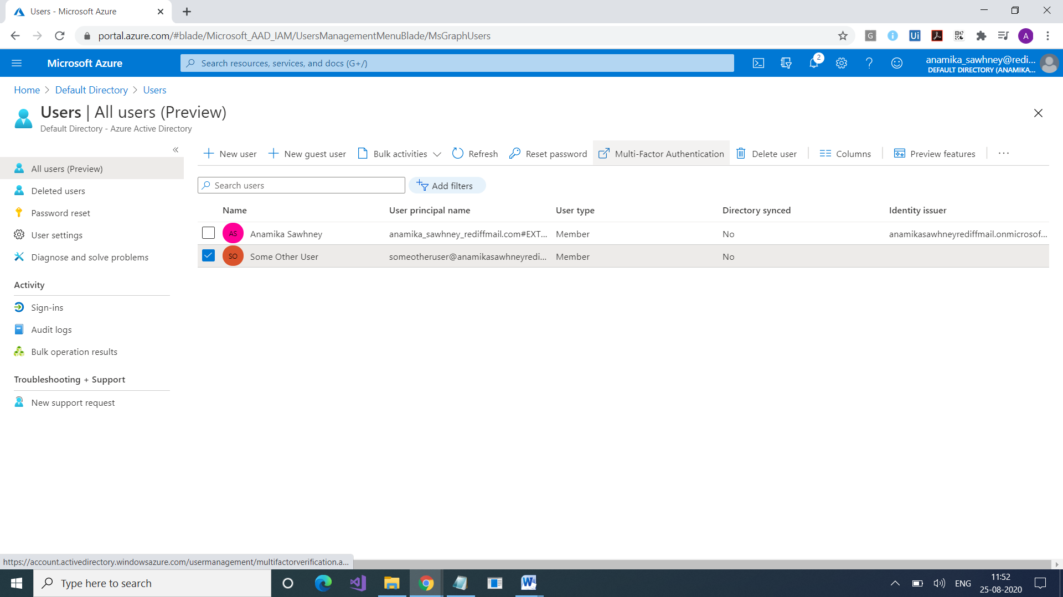

Select User and click on Enable

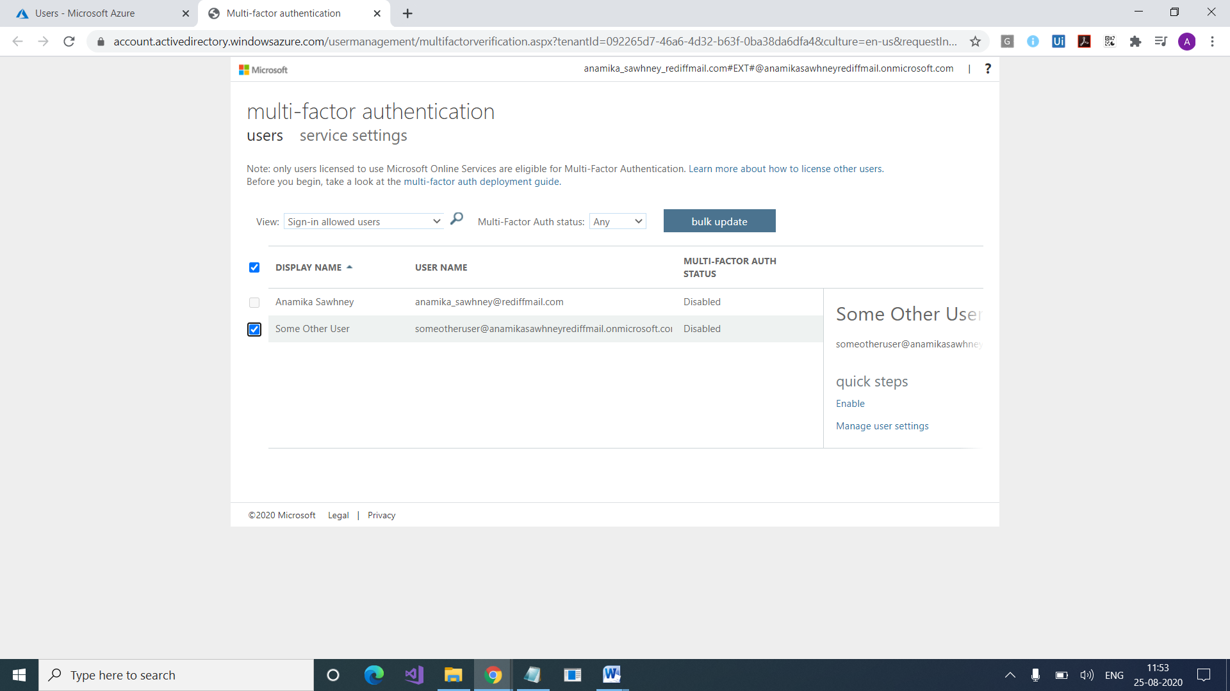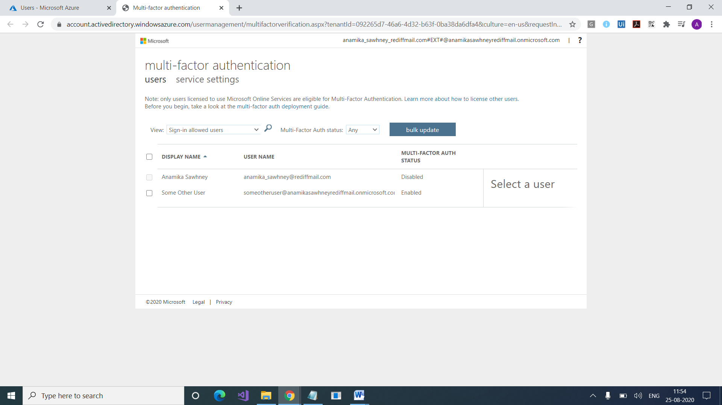

Select User and select Service Settings

<https://www.microsoft.com/en-us/p/microsoft-authenticator/9nblgggzmcj6?activetab=pivot:overviewtab>

